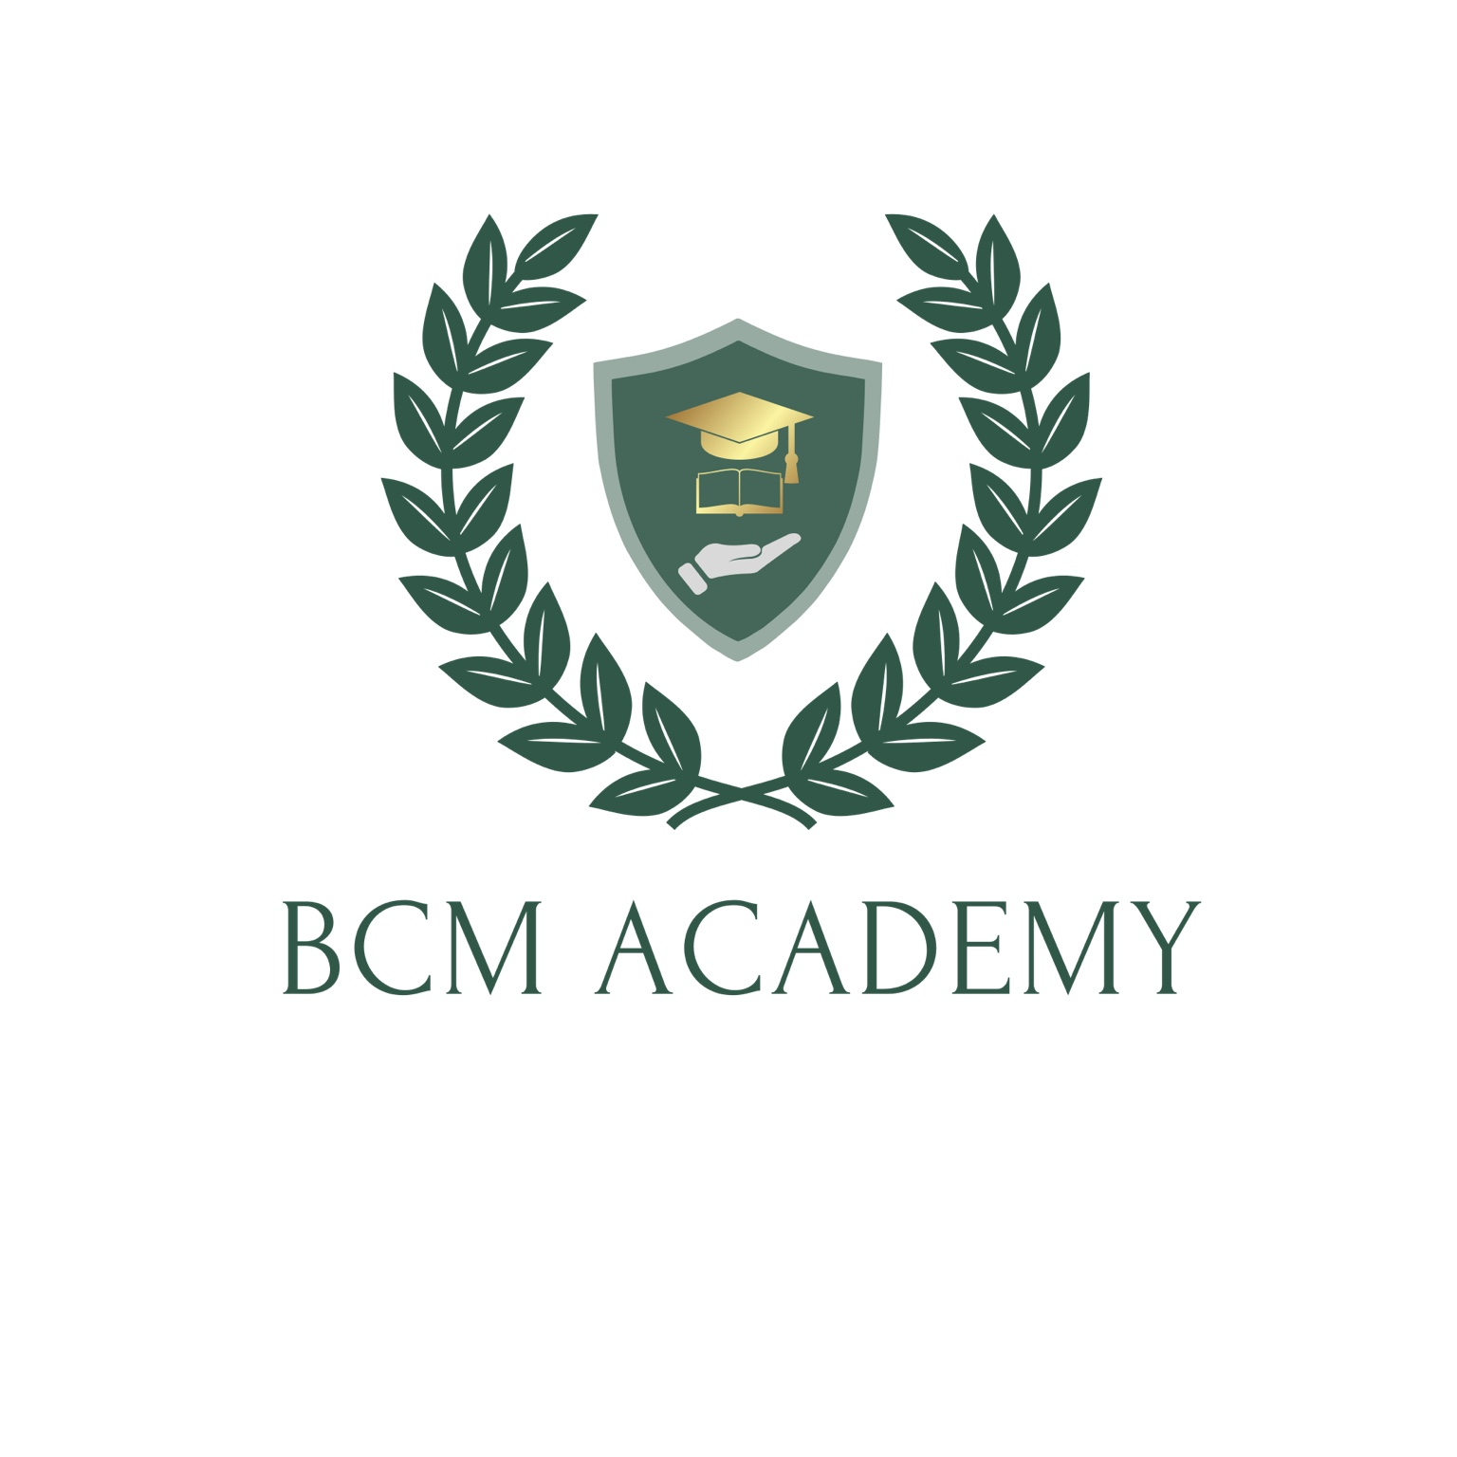

BCM Ltd

Complaints Policy

Contents
Introduction 3
Reporting 3
Complaints Procedure 3
Stage 1: Informal Complaint 3
Stage 2: Formal Complaint 3
Submitting a Complaint 4
Upheld Complaints 4
Right of Appeal 4
Confidentiality and Whistleblowing 4
Contact Details 5

Introduction
BCM Ltd aims to provide a good level of service to support our learners and other stakeholders in relation to the delivery and assessment of all our courses and any related qualification. This document outlines the procedures to be followed should you wish to make a complaint relating to any aspect of our service.
This procedure is not to be used for appeals (including appeals against assessment decisions), or for reporting malpractice/maladministration, in these circumstances you should refer to BCM Ltd Appeals or Malpractice Policies.

Complaints Procedure

Stage 1: Informal Complaint
You are encouraged to address any issues directly with the relevant Course Tutor or appropriate member of staff as soon as possible, however if a satisfactory resolution cannot be found then learners should proceed to the next stage.

Stage 2: Formal Complaint
Complaints should be made in writing, by email or post using the contact details at the end of this document and addressed to: tauqir@bcm-academy.co.uk.

Formal complaints must be made within [enter number of days e.g. 20 wording days] from the date that the issue occurred. We reserve the right to not investigate any complaints made outside of this period.
Your complaint will be acknowledged within [x ] working days from receipt.
We will appoint a member of staff, who has no direct involvement in the issue being raised and no personal interest in the outcome of the complaint, to investigate.
You may be contacted during the investigation into the complaint if further information or clarification is required.
You will normally be informed of the outcome of your complaint, in writing, within [x] working days from receipt, however this may take longer if the complaint is complex, we will aim to keep you updated.

Submitting a Complaint
Complaints made in writing, by email or post using the contact details in this document and must be received as per the timescales outlined above.
The following details must be provided at the time of writing:
- your full name and contact, including email and telephone number;
- outline of your complaint, providing as many details as possible, including the subject dates and times if know;
- details of any previous correspondence or communication relating to the complaint;
- copies of any documentation and/or correspondence relating to the complaint;
- an indication of how you would like to see the complaint resolved.

Upheld Complaints
If your complaint is upheld, we will take appropriate action, examples may include:
- identify any other learner/stakeholder who has been affected;
- correct the failure and the circumstances where this cannot be done aim to mitigate any impact;
- review procedures;
- arrange for staff training;
Where behaviour of staff is deemed inappropriate internal disciplinary procedures may be implemented, however, the details of such procedures cannot be shared.

Right of Appeal
If you are dissatisfied with the outcome of a complaint or believe that the procedures as outlined in this document have not been applied in a fair or objective manner you may appeal using our Appeals Procedure.

Reporting of Complaints relating to Regulated Qualifications
For regulated qualifications, we are required to report immediately to the relevant awarding organisation or regulatory body any complaints relating to:
- equality in the delivery of regulated qualifications,
- the processing of personal data or compliance with data protection legislation,
- the integrity of the regulated qualifications
- any matter that may give rise to a potential Adverse Effect (as defined by the qualification regulators)

Whistleblowing
If you wish to complain anonymously, please confirm that you do not wish your identity to be disclosed at the time of writing. In such cases we will investigate the complaint where possible and only if there is supporting evidence. We will try our upmost to maintain confidentiality, however, during the investigation your identity may become evident to others involved.
The relevant awarding organisation or regulatory body may also require copies of any documentation, this could also lead your identity being revealed. We will of course take all reasonable steps to inform you in advance.

Contact Details
BCM Ltd
20 Kingsmead, London, EN5 5AY
Telephone: +44 7920 803 459
Email: tauqir@bcm-academy.co.uk

Uncontrolled when printed
Tauqir Ahmed | Tauqir Ahmed | 4 | 23rd March 2025 | 23rd March 2025
Tauqir Ahmed | Add name | 1.1 | 26th January 2022 | 26th January 2023

