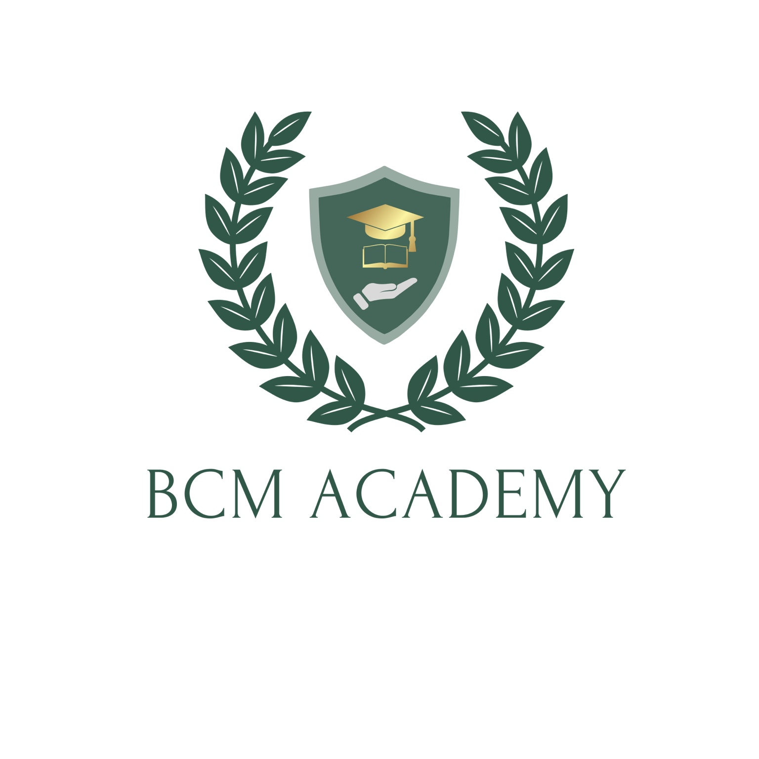

BCM Ltd

Declaration of Authenticity
Declaration of Authenticity

Learner Name................................................. Learner Number.............................

Qualification Title....…………………………………………………………………………………...

Unit Number and Title...............................................................................................................

BCM Ltd

Each Learner is required to sign a declaration, before submitting their coursework to their subject tutor/assessor, stating that the work is their own and that any assistance given and/or sources used have been acknowledged. Ensuring that they do so is the responsibility of the centre.

Learners
The work you submit for your assessment must be your own. Should you copy from someone else, allow another Learner to copy from you, or plagiarise in any other way, you may be disqualified for the unit concerned.

Declaration by Learner

I have produced the attached work without assistance other than that which is acceptable under the scheme of assessment.

Learner name....................................................................................................................

Learner Signature................................................................. Date....................................

Declaration by Assessor
I confirm that:
- The Learner’s work was conducted under the conditions laid out by the qualification/assessment specification.
- I have authenticated the Learner’s work and I am satisfied that to the best of my knowledge, the work produced is solely that of the Learner.

Assessor name.................................................................................................................

Assessor signature................................................................. Date.................................

Questions or Queries should be directed to BCM Ltd

